Space and Connections
Advanced tactics

This article tells about the ways how black should develop the attack. It is meant for advanced level players. Indeed, even beginners may try to learn some ideas from here but it is recommendable that those players should be well familiar with “basic tactics” first and after that continue studying “advanced tactics”.

In the past 10 years, I have tried to find answers to the questions – How should black develop the attack in the positions where is no straight win? How to make the black advantage to become a victory? How to force the opponent to make weak moves as white? What are the conditions that make the winning development possible?
Through the years, my opinion has changed. At first I believed that the straight and intensive attack using the best attacking moves is enough to reach to the victory. Even I could prove it in practice. Whenever I played as black, I used the straight style, taking advantage of the good structure of the stones. Sooner or later my opponents couldn’t bear the pressure and they made a mistake that let me win. If you have an access to renju databases then you may notice that many of my games that I played in around 1989-1993 ended often very fast, I won as black without using too many stones. Since 1993 I had a chance to play regularly in world class tournaments. In those tournaments my opponents were very strong, I was sometimes shocked and disappointed when my straight style seemed to be ineffective against top players. These players knew how to defend against the primitive straight style, no matter how powerful my moves were. I realized I have to change my tactics if I want to keep myself in the world top level. I started to search for the new technique how to develop the black’s attack. However, I was not very successful, I couldn’t find any formula or idea that would have been good enough. In the years of 1993-1997 I began to favor the white stones because I had developed my tactic there quite well. For example, in the Team European Championship in 1994 I played 9 games as white (!!) and only one game as black. Finally, by 1997 my new tactics for black was ready. I made a total change in my playstyle – I replaced the concept “straight and intensive development” with the concept “space and connections”.
Of course, at that time, those concepts didn’t have any “names”, I just made them up for this article.
My games became “longer” in the number of moves, but on the other hand, the winning rate raised as well.
The conclusions from my observations:
- If the white doesn’t make any theoretical mistake, then black cannot win in the opening.
- If black doesn’t win by 25th move, then it is not very probable that black can win after that by using one area or one source of power only.
- When there is not much free space then white doesn’t have to worry too much if black has too many attacking material (lines that can create threes or fours) since the black attack often fails due to lack of space despite the amount of the attacking material.

The conclusions are based on studying hundreds of my own games, also other top players games. The first conclusion is the easiest one, I am sure that the most of us have realized that already. At this point, we feel the importance of renju theory book.
The second conclusion, it took me many years to work it out. I saw many games that lasted over 25 moves, and very seldom happened that black was able to show powerful attack in one area only without using any additional help from other areas.
However, many strong players still used straight style and failed their attack later, and they never learned their lesson from that. The kept playing in the same style again and again. At that time I realized that it was wrong and insufficient to attack in one area only, but I didn’t know how to do otherwise.
It took the most time to work out the third conclusion. I had realized the importance of the board edge long time ago, but I didn’t know that small space was one of the keys for white’s defense. White could easily let the black go to attack in the corner or area where the space was narrow and despite the black huge advantage there, the attack failed because of the lack of space. Soon I became very good at playing as white – I sensed the board edges very well and often provoked black to go to attack there. I knew the black attack was going to fail because there was not enough free space.
I put the conclusions together – I cannot hope for opponents’ silly mistake in the opening stage. I have to increase the power of the attack step by step using more than one area. I have to make sure that I have enough space in the winning area.
The first conclusion leads to the second conclusion – the strong opponent doesn’t let me win in the opening stage, so the game will last over 25 moves at least. That means I will have to use more than one area to build up my attack, since it is very unlikely to win by using one area only when there are over 25 stones on the board already.
So, I realized that it was important to connect more than one area of my attack. Connect! That is the key! We always think about connections in the simple level like connecting lines with each other, such as 3x3, 4x3, etc. But we seldom think about ways of connecting the whole attacking areas. Now I am convinced that connecting the attacking areas is the key to the victory. But not only connection is important. Also space is important. There is no much use of my excellent connections if I do it in the narrow space, near the edge or opponent’s stones. So both space and connections are important. Space and connections!!

It sounds very easy in theory, but hard to imagine it in practice without examples. Hereby I will go through the tactics ideas again in detailed way, using many practical examples.

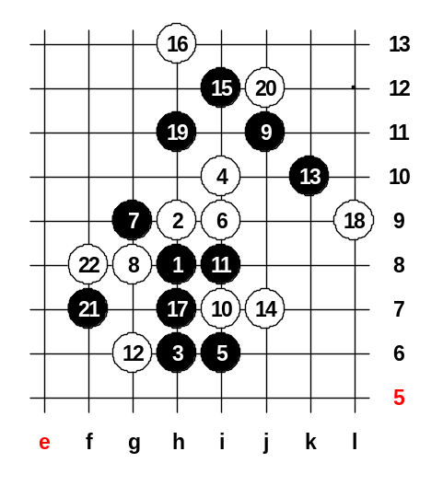
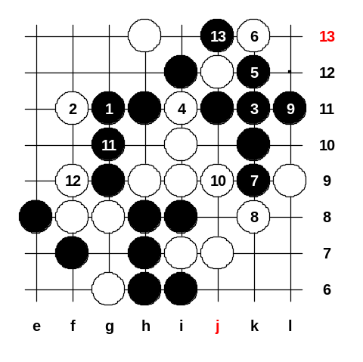
The first example comes from the classical d11 opening pattern. Until move 22 the sequence is very common. Black can try many kinds of attack as he has some attacking source in all sides of the board. However, attacks in those sides contain some problems. Which 23rd move is good? If black would try to attack in lower and right side then white can defend the attack with careful moves. How about left upper side? In the first look it seems that 23-g11 is a good move because if 24-i11 then 25-e11. But in the second look you will realize that white doesn’t have to block the black’s three from the middle, white would move 24-f11. After that, black seems to have connection idea 25-k11, 26-i11, 27-k12 but white’s three (28-k13) will ruin the black plan to connect j13 and L11.
So, the attacking plan in upper side doesn’t work because of white’s defense three above. What could be the solution to make that attack possible despite the white’s three? The solution idea is this – black needs a stone to e8 !! If black has a stone at e8, then the attacking idea in upper side will work fine – black will have VCF if white plays the three in k13.
How to get the black stone to e8 and still to have a black’s turn to move? Black needs to use the lower and left side source to connect to the e8 key point. It is too early to play 23-e8 immediately because after that the black’s left side is still too passive, and white can activate the game in upper area by 24-g11 and so black would be in big trouble.
The key stone e8 must be connected slowly, step by step. Black must make the moves in lower area that does not let white go to play actively above, such as g11. If black move is too passive and doesn’t contain any direct attack threat at all then white can play immediately on the right side, such as L7 or any other move of the similar kind.
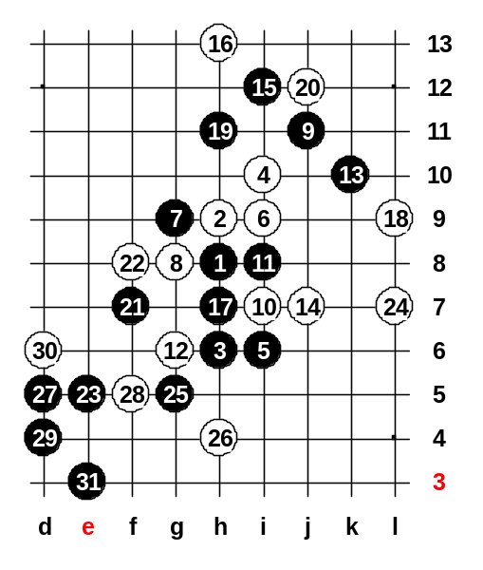
How to find the active move for black on the left side? There is no formula for that. The player must think of some options here. How about 23-f5? Looks active, but in fact, the black attack will fade out soon, so white can simply play 24-L7.
How about 23-e5? Does black have continuation to his attack if white goes 24-L7? Yes, black can continue attack with 25-g5. White will have to play 26-h4 in order to avoid possible VCF threat move at e7. But in case of 26-h4 black will still have a way to continue attack – 27-d5, 28-f5, 29-d4 (see the diagram).
In case of 23-e5 black keeps the activity on the left side. White has to defend the left side.
The fact is that white must play a stone in the left area in defense, but where exactly?
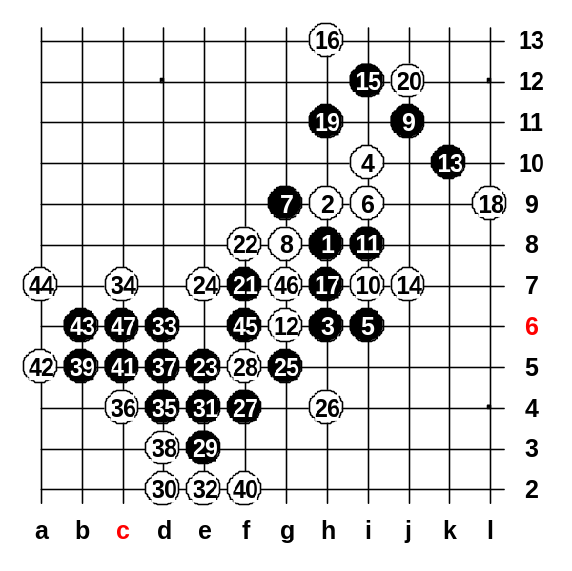
Lets suppose that white already noticed black’s idea to connect to e8 and so white will try to stop black connecting lower area to e8 point. White will try 24-e7. It is very good connection breaker and now black cannot reach to e8 anymore. But black doesn’t need to connect to e8 in that case because after 24-e7 the black has win in lower area.
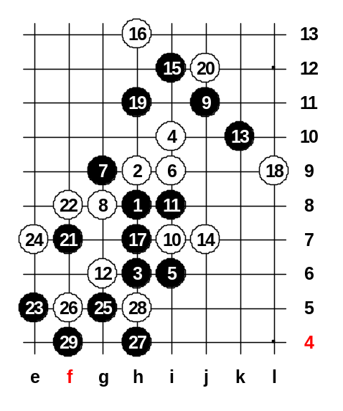

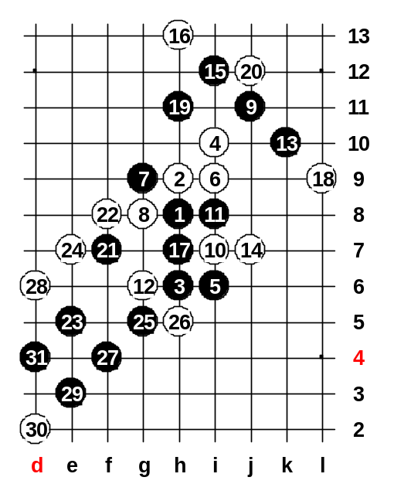

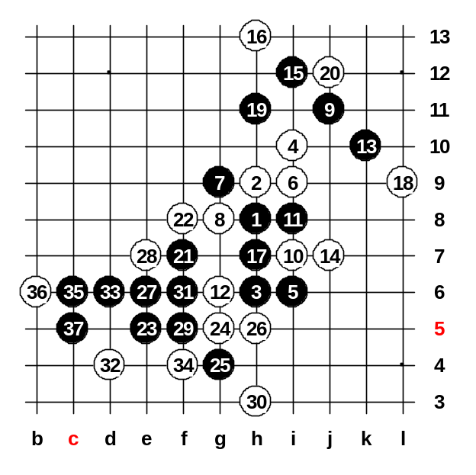
As you can see, white cannot use the defense 24-e7 because black attack is too powerful in lower side. White has to search another 24th move. It seems that the black connection between e5 and h5 is too powerful, so white has to try to break it – 24-g5 seems the best for that purpose. This 24th move was three times played in the last World Championship A-final by Stefan Karlsson. He believed this 24th move is strong enough to end the black attack. But in fact, black still has a good chance to connect to e8.
Move 25-g4 is the strongest. Here, white can sense the danger of the connection, so white tries an active attempt by 26-h5. The way how black wins after that, you can see from the diagram.
There are no other active 26th moves possible. If 26-j5 then 27-e6.

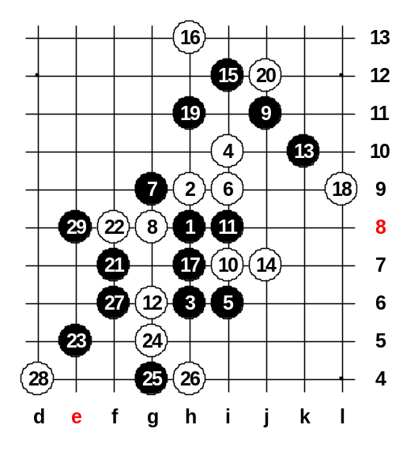
Finally, white is forced to use the move 26-h4. Now, black still cannot go directly 27-e8 because of 28-e7, 29-f6, 30-j5 and white would win.
Therefore 27-f6 is necessary to be played first. White must play 28-d4 to avoid the loss in left lower corner.
And finally, black has a chance to play move e8 and still force white to make a next defense move nearby – d7 or e7.
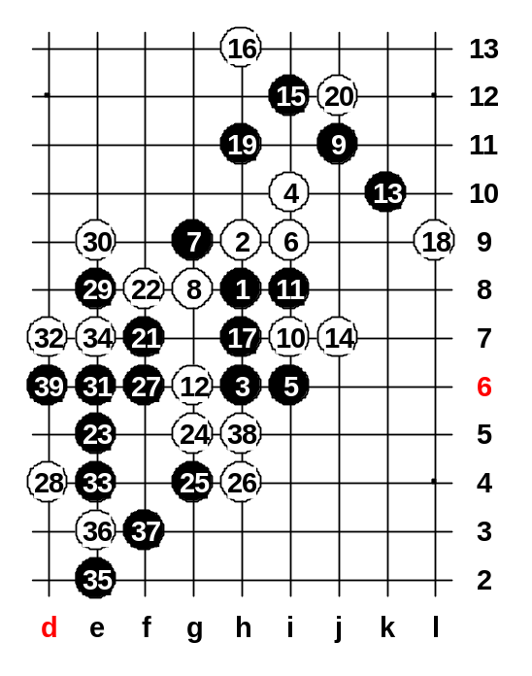
Here is one example diagram about white’s attempt to play the 30th move closer to upper area. In this case, black wins in the left lower area quite easily.
If 30-f9 then 31-e6, 32-e7, 33-f5, 34-h3, 35-c6 and black wins.
This diagram proves the black power on the left side after 29-e8. White is forced to play either 30-d7 or 30-e7.

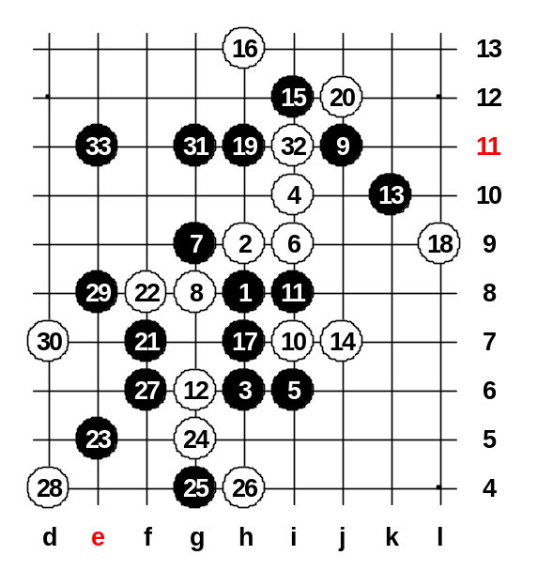

Finally black has achieved the goal – important connection between lower and upper side had been made through e8 point.
Because of stone at e8, white cannot play 32-f11.
After 33rd move black has won.

This example was perhaps very difficult, but it explains very well the importance of connections. Sometimes one connected stone is enough to help the small attack to become a victory.

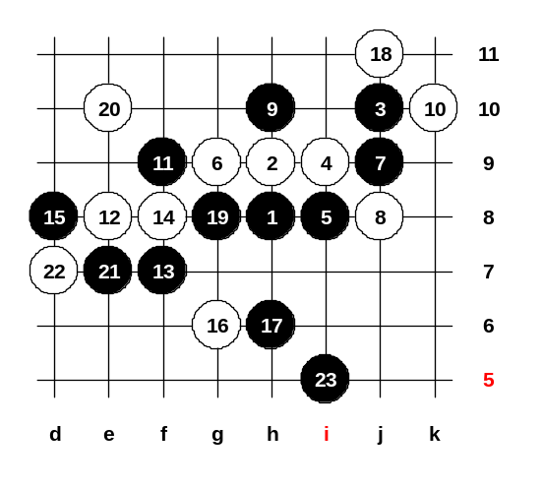
Now, I want to show you the example of using the space for black’s attack. We will take a look at game Soosyrv-Sagara, played in the last World Championship finals.
Ants Soosyrv played as black, the opening was traditional d3. After the 22nd move black had got the initiative. But the black structure is not too powerful yet. How to make it stronger? Ants used the classical “space” method – he played 23-i5, the diagonal stretch-out to the space. In case of such development moves black must be careful and make sure that he has a continuation to the attack in case white will try the attempt of the activity on the other side. In this case, there was no problem. If white would play 24th move in the upper side then black next move to h5 or j5 would be a VCF threat.
Making diagonal line into the space is usually the strongest move in space-development. Please note that black only created one line in 23rd move, whereas he could have had a chance to play 23-h4 (two lines) or 23-h7 (three lines).
But you have to remember that having good space for the attack is much more important than having many lines. If black had played 23-h7 and created three lines then white would have easily blocked the black’s attack with almost any move. Remember, without the space, the many lines are useless.
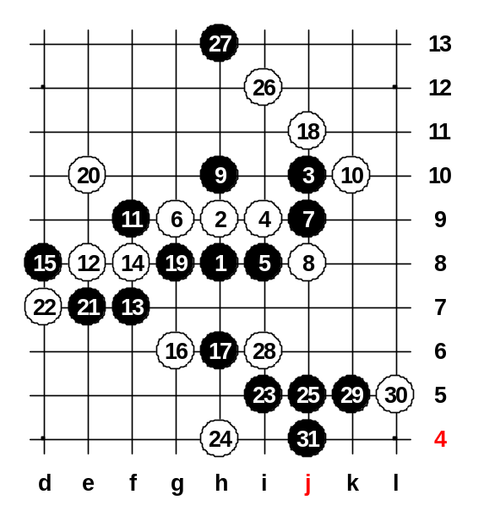
Because of the good space around the i5 move, black has so many different good choices to continue the attack depending on white’s next defense move. Usually, black can almost guess the white’s next defense move and this helps black to plan the continuation of the attack. In this game, it was quite easy to predict that white will have to defend at 24-h4. Black had already prepared the next attacking move, 25-j5, another space-move. The idea of any “space-move” is to give enough free space for black stones (not too inside the position), and also keep the distance from white’s defensive stones. Note that move 25-i6 would not have been a good move because there is not enough free space around it and white defense stones are closer than in case of 25-j5. Besides, if black would play 25-i6 then white could surround black stones by 26-j5.
So, 25-j5 is the best move. And just as before, it is so easy to predict white’s defense move – 28-i6. One of the space development tactics is to force white make weak moves, such as stones inside the pattern (just like 28-i6).Now, black has the complete control over the space and it is time to make the development of many lines, see the moves 29 and 31. Black has got both space and many lines for the attack. If you compare this with 23-h7 which was many lines too, can you see the difference in black power? Now black’s many lines are really meaningful because of free space around them.
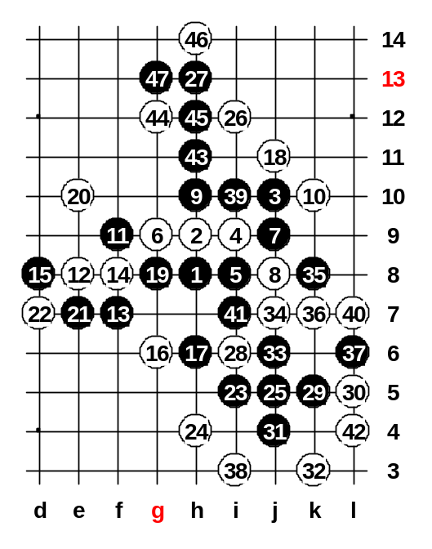
However, a good player should count as many steps forward as possible before beginning the attack with moves 29 and 31. Ants had planned a soft pause move 35-k8 in his attack. After the 36-k7 black began the straight attack until the victory. There is also one beautiful connection idea in this game – if 40-h11 then 41-c7 with the double VCF threat.
In my opinion, if black had used any other development move in 23rd and 25th move then white would have defended black’s attack without big problems. So, sometimes the space development is the only way to win.

Here is one more example about space-move and the connection idea.
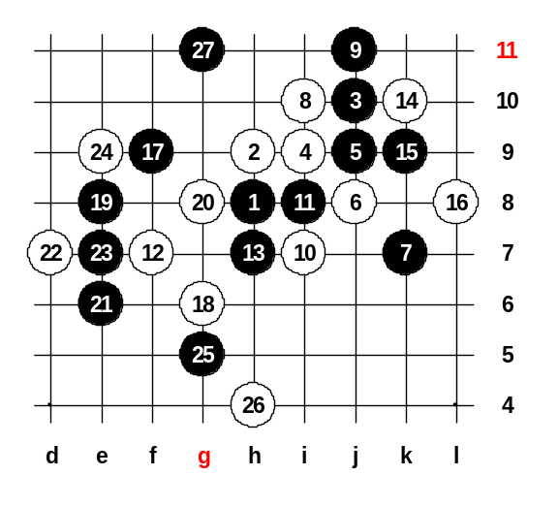
Most of you have already seen that game, it was played in the third game in the match against Nakamura. Until move 26 the game was played in peaceful development style, no sharpness, no space-moves yet. In fact, black’s moves 23 and 25 were made as preparation moves before the space development because space move is usually not a VCF threat, so, black has to be sure that white has no activity of his own before black plays a space-move. So, in this game moves 23 and 25 eliminated white’s active structures. Move 27-g11 is absolutely the best move for black. It has two ideas. The first idea is taking the good space for black. The second idea is that this stone is the first step in long way connecting idea - black wants to connect e5 to j12 and make it become a key of the victory.
As usually a space move doesn’t make many lines, usually only one line. But I remind again, many lines are not important. Space is important. Once black will have good space, he can make many lines later. And those many lines will be more powerful.
Nakamura as white underestimated the space move strength and he played 28-i11. His idea was obvious. He assumed I would continue careful style and block his line at 29-i12 and after that Nakamura would have a chance to play 30-g12 for example.
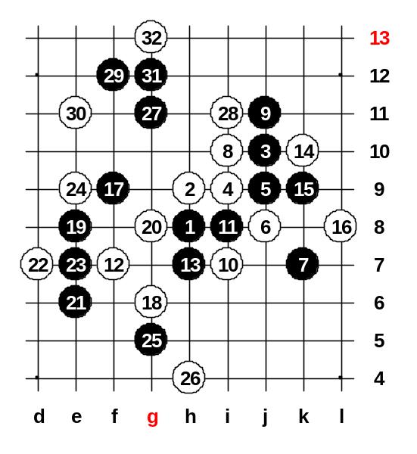
Black should not follow that provocation but should continue with space development. So I did.
I played 29-f12 – another space-move. This time, it contains two lines, that makes it even more powerful. Black is getting closer to the left lower side step by step. White tries to break the connection by 30-e11 but now black can make a source development move – create many lines with 31-g12. White’s move 32-g13 was expected and logical.
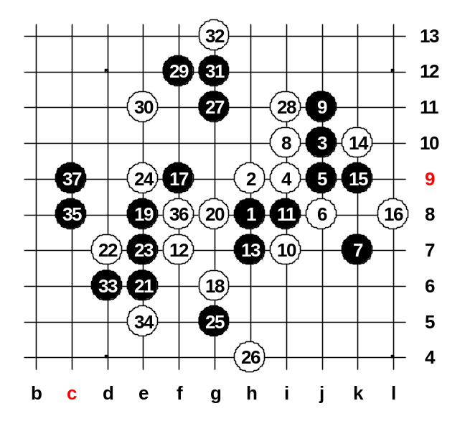
What is the result? Black controls the space and the attack. Thanks to the space development, black has got much open lines as a source of the attack. However, sometimes space attack alone is not sufficient. Need some additional connection. So I continue the idea of connecting lower side with the upper side. I played 33-d6, forcing black to play 34-e5. Now I have already got one connection through f8 point. But it seems to be useless connection. I cannot get any benefit from it. I needed an effective connection, I would even sacrifice many of my attacking source for the sake of one good connection. The move 35-c8 is that kind of move – black gives up three of his attacking lines after 36-f8. But black does not need those lines, black needs the connection to d12 point. Move 37-c9 is the VCF threat. No matter how white would block that VCF threat, black will still have a chance to get a stone to either b10 or c11 and that would be enough for black to make it become a win with moves e13, j12, h12, i13.
So in this game, black used both space and connections tactics to make it become a black victory.

Please note that sometimes the space move is not effective and worsens the black position. What are the reasons of that? Why is space move weak sometimes? You can read about it in the next article.

